7: Create a Pivot Table and Find the Maximum and Minimum Sale Value of the Items

Aim
To create a Pivot Table using Pandas and determine the maximum and minimum sale value of each item.

Algorithm
- Import the Pandas library.
- Create or read the dataset.
- Store the data in a DataFrame.
- Create a Pivot Table using pivot_table().
- Set Item as the index and Sale_Value as the values.
- Use the aggregation functions max and min.
- Display the Pivot Table.

Dataset (sales_data.csv)
Item | Unit_Sold | Sale_Value
Laptop | 10 | 50000
Laptop | 15 | 75000
Mobile | 20 | 30000
Mobile | 18 | 28000
Tablet | 12 | 24000
Tablet | 15 | 30000
Printer | 8 | 16000
Printer | 10 | 20000
Keyboard | 30 | 15000
Keyboard | 25 | 12500

Code:

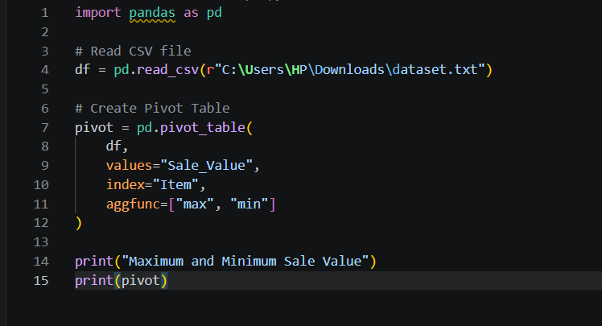

OUTPUT:
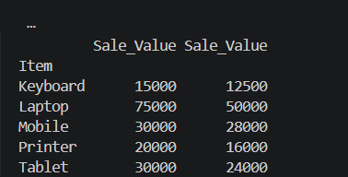

Result
Thus, the Pivot Table was created successfully, displaying the maximum and minimum sale value for each item.

8: Create a Pivot Table and Find the Item-wise Unit Sold

Aim
To create a Pivot Table using Pandas and calculate the total units sold for each item.

Algorithm
- Import the Pandas library.
- Read the dataset.
- Store the data in a DataFrame.
- Create a Pivot Table.
- Set Item as the index and Unit_Sold as the values.
- Use the sum aggregation function.
- Display the Pivot Table.
Dataset (sales_data.csv)
Item | Unit_Sold | Sale_Value
Laptop | 10 | 50000
Laptop | 15 | 75000
Mobile | 20 | 30000
Mobile | 18 | 28000
Tablet | 12 | 24000
Tablet | 15 | 30000
Printer | 8 | 16000
Printer | 10 | 20000
Keyboard | 30 | 15000
Keyboard | 25 | 12500

Code:

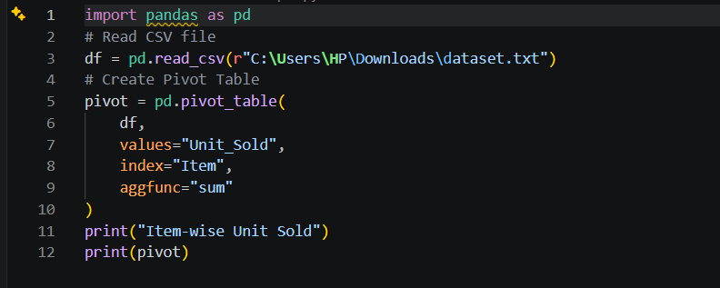

output

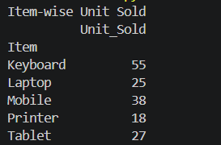

Result
Thus, the Pivot Table was created successfully, showing the total number of units sold for each item.

